Exercise - 3

Introduction to Databases

Date:- 06-02-2019

Problem Statement: There can be multiple customers, who can place multiple orders on the site. Now a sales person can handle these orders will distribute into multiple sales persons (One order will be assign to one salesperson only). So a sales person can have multiple orders of multiple customers

1. Create Database.
2. To create the database ,following command is used.

mysql> create database database_name;

2. To see all the databases

mysql>show databases;

3. To use database

mysql>use database_name;

4. To see on which database currently work

mysql>select database();

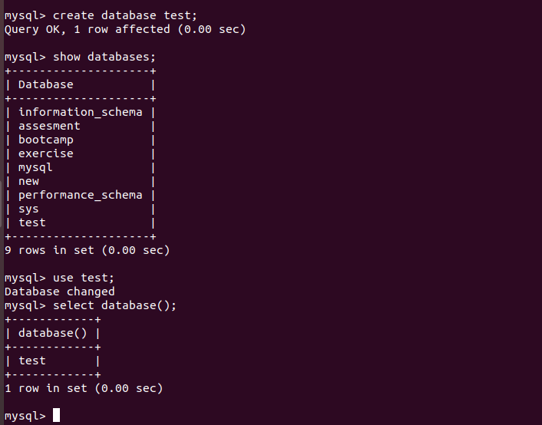

1. Design Schema .



1. Create tables

Inside database now we will create tables.

Query to create tables:

Create table table_name(

Column _1 datatype,

Column_2 datatype,

………………………..);

For the given problem ,as discussed in schema total three table will be created.

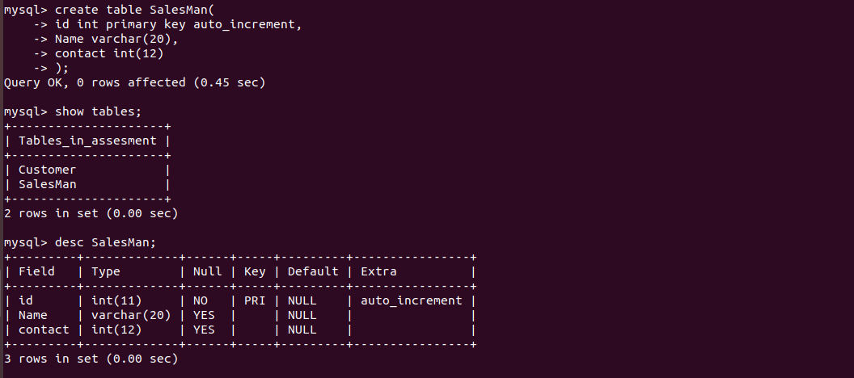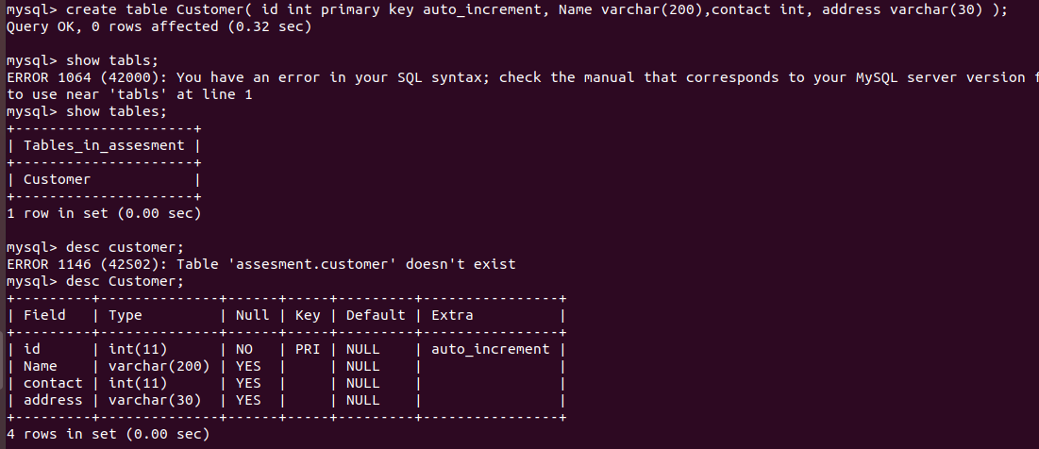

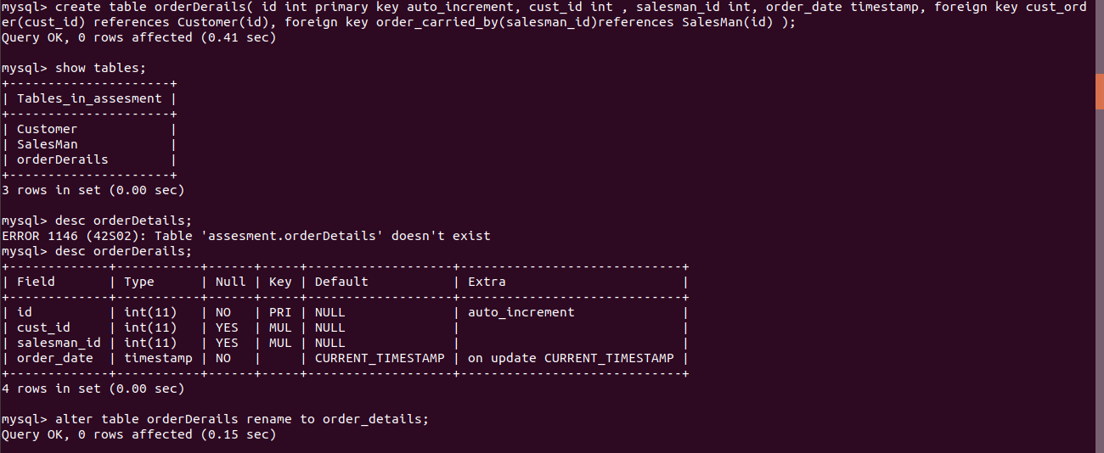

1. Insert sample data .

Query to insert data into table:

Insert into table_name (column1, column2, column3, ...)

values(value1, value2, value3, ...);

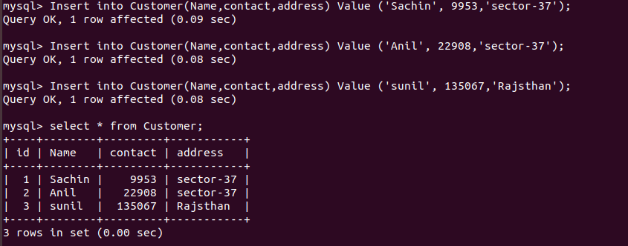

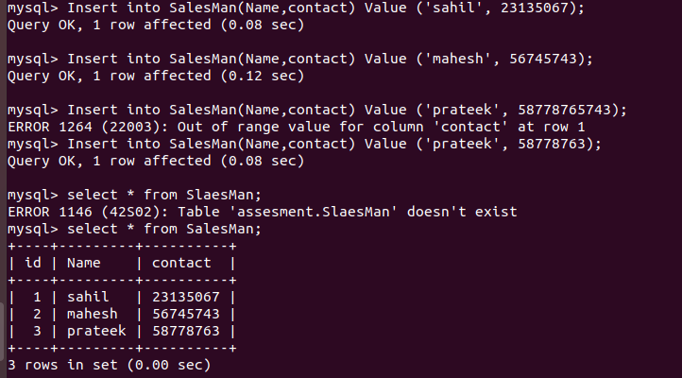

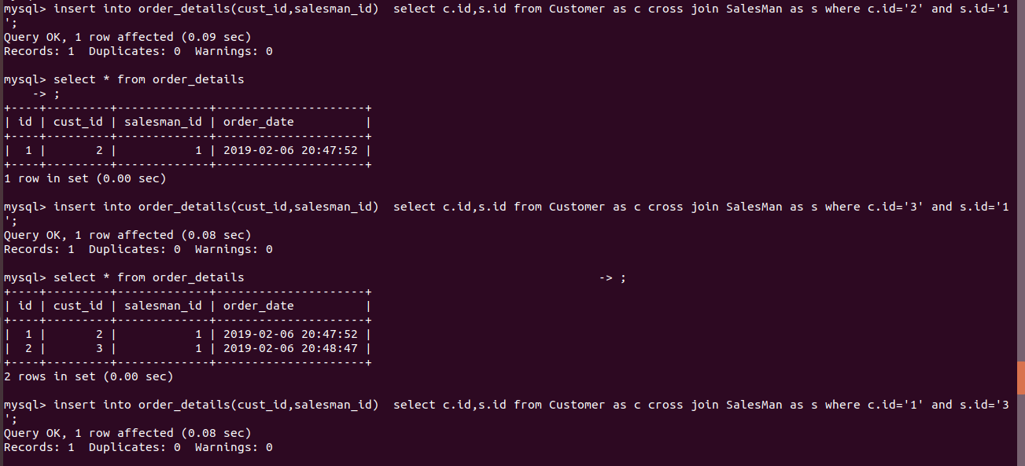

1. Find the sales person have multiple orders.

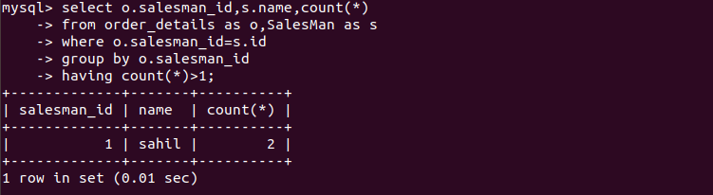

1. Find the all sales person details along with order details.

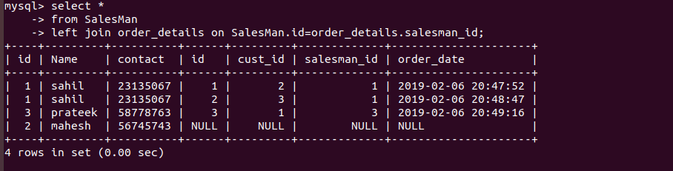

1. Create index.

A database index is a data structure that improves the speed of operations in a table. Indexes can be created using one or more columns, providing the basis for both rapid random lookups and efficient ordering of access to records.

Query to create index is:

mysql>create index_name

on table_name (column1, column2, ...);

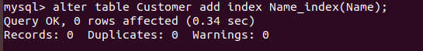

1. How to show index on a table.

Query to show index on table is:

mysql>show index from table_name;

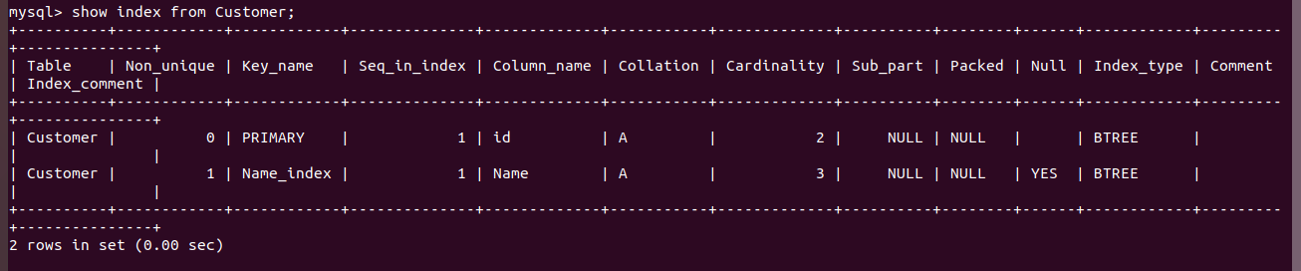

1. Find the order number, sale ,person name, along with the customer to whom that order belongs to.

